## **Hands-On Activity: SQL sorting queries**

1.

Question 1



## Activity overview



So far, you’ve learned about SQL and used SQL queries to interact with databases. In this activity, you’ll practice sorting data by using SQL queries with ORDER BY and WHERE clauses.

By the time you complete this activity, you will be able to write queries that sort data depending on your needs. This will enable you to organize and use data more efficiently in your career as a data analyst.

## Sorting with SQL



To practice sorting data with SQL, you’ll query the CDC Births Data Summary public dataset. The queries you write will help you obtain some answers about which counties in the United States have the most and least births in the years 2016-2018.

### Load the dataset



1. Log in to [BigQuery Sandbox](https://cloud.google.com/bigquery/docs/sandbox). If you have a free trial version of BigQuery, you can use that instead. On the BigQuery page, click the Go to BigQuery button.

* Note: BigQuery Sandbox frequently updates its user interface. The latest changes may not be reflected in the screenshots presented in this activity, but the principles remain the same. Adapting to changes in software updates is an essential skill for data analysts, and it’s helpful for you to practice troubleshooting. You can also reach out to your community of learners on the discussion forum for help.

2. If you have never created a BigQuery project before, click CREATE PROJECT on the right side of the screen. If you have created a project before, you can use an existing one or create a new one by clicking the project dropdown in the blue header bar and selecting NEW PROJECT.

3. Name your project something that will help you identify it later. You can give it a unique project ID or use an auto-generated one. Don’t worry about selecting an organization if you don’t know what to put.

4. Now, you’ll see the Editor interface. In the middle of the screen is a window where you can type code, and to the left is the Explorer menu where you can search for datasets.

5. Click + ADD DATA at the top of the Explorer menu, then Explore public datasets from the resulting dropdown.

6. In the Search Marketplace bar, type sdoh_cdc_wonder_natality.

7. Click the CDC Births Data Summary.

8. Click View Dataset. This will bring you back to the BigQuery Sandbox interface in a new tab.

* Note: This may pin the bigquery-public-data dropdown to the Explorer menu. You can use this to browse datasets and tables.

9. Click back to the Editor tab. This is where you’ll use SQL during this activity.

10. Copy, paste, and run the following query to display the first 1,000 rows of the county_natality table:

Select * from

`bigquery-public-data.sdoh_cdc_wonder_natality.county_natality`

LIMIT

1000

SELECT

*

FROM

After the query has run, your results should appear like this:

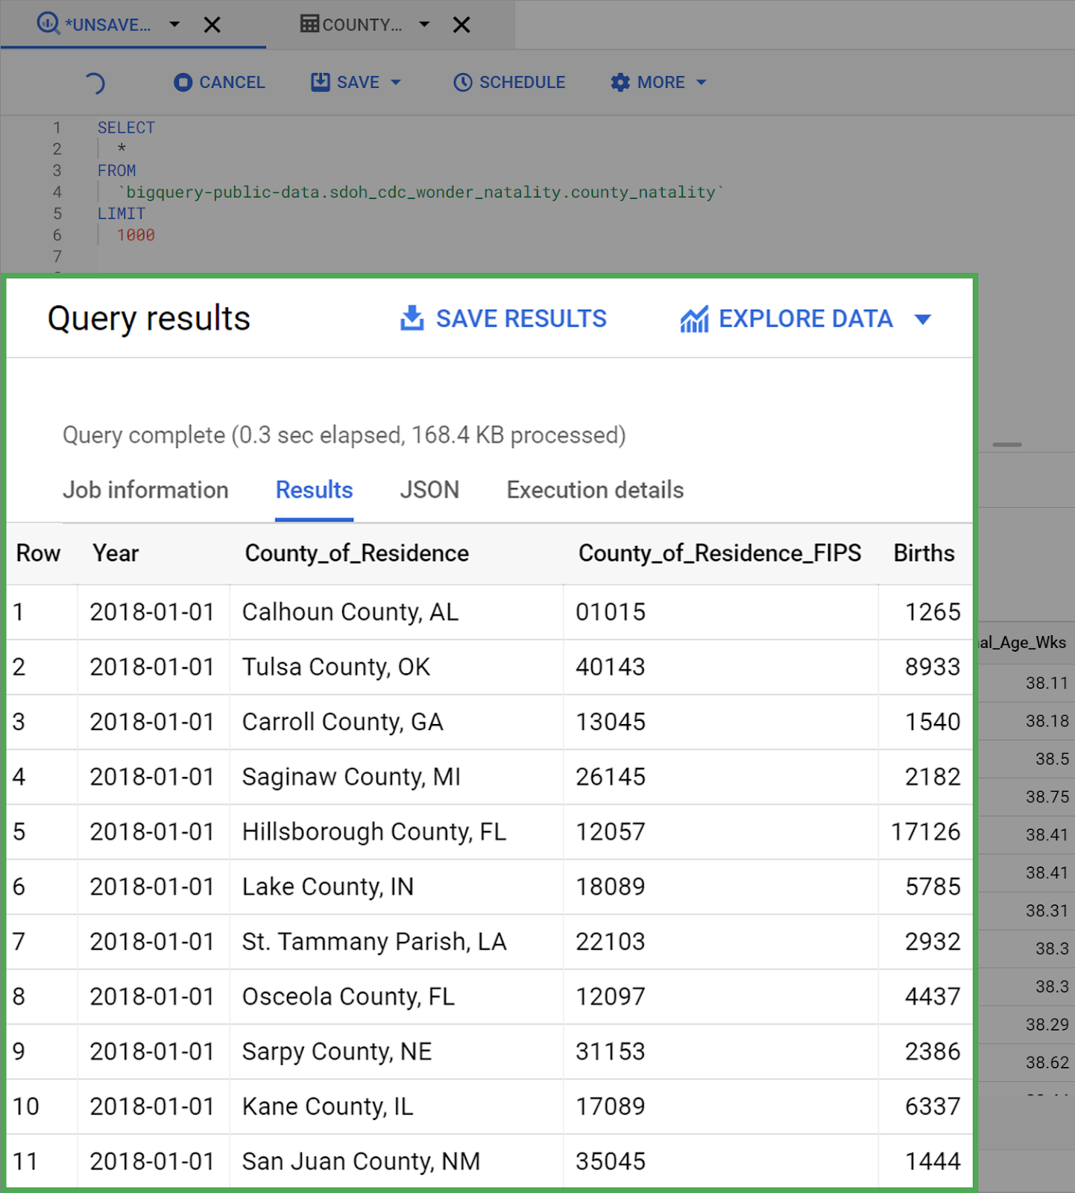

### Use the ORDER BY clause



Examine the dataset you just loaded. Take a moment to familiarize yourself with the columns and get a feel for what each can tell you. Notice that the table is organized by the ID column.

Now, imagine you were asked by your manager to figure out which 10 counties had the lowest birth count for 2016-2018. You could accomplish this by modifying your query to use the ORDER BY clause.

Copy, paste, and run the following query:

8

10

The results of your query should appear like this:

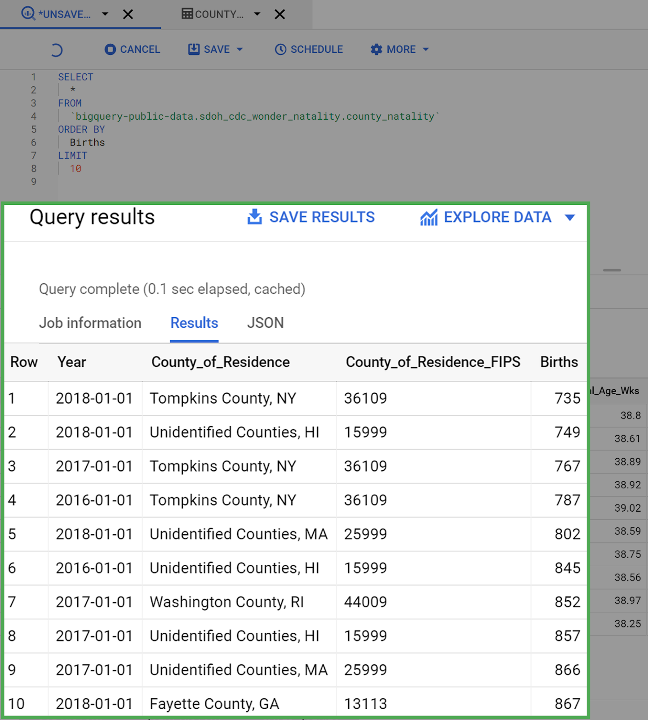

You may have noticed that the query did not specify whether it should be sorted ASC (ascending) or DESC (descending). When this is not specified, SQL defaults to sorting by ascending order. You can run another query to confirm this.

Copy, paste, and run the following query that includes ASC:

SELECT

*

FROM

`bigquery-public-data.sdoh_cdc_wonder_natality.county_natality`

ORDER BY

Births

ASC

LIMIT

10

You’ll find that the results did not change. Notice that Tompkins County, NY, had just 735 births in 2018—the lowest birth count of any county in the US between 2016-2018.



### Use DESC to reverse sorting order



Now, modify the query to sort in the other direction, returning the top 10 counties with the highest yearly birth counts between 2016-2018.

Copy, paste, and run the following query:

1

SELECT

*

FROM

`bigquery-public-data.sdoh_cdc_wonder_natality.county_natality`

ORDER BY

Births

DESC

LIMIT

10

Your results should appear like this:

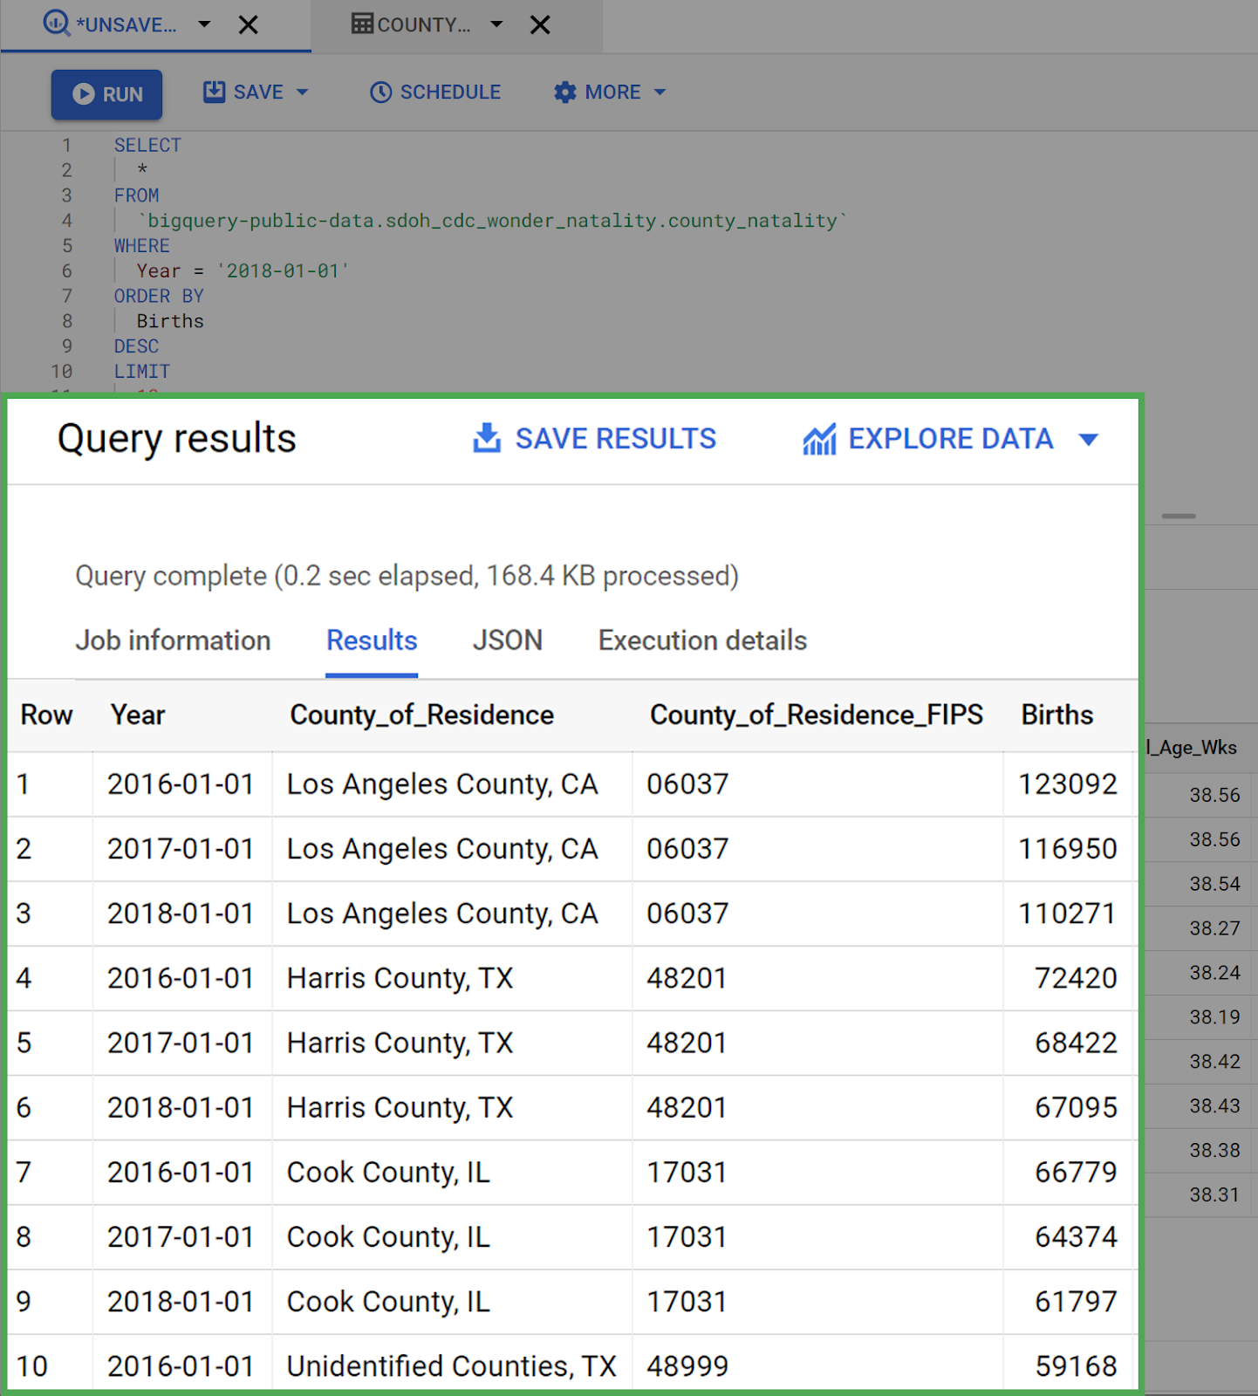

Now, the query returns the 10 rows with the largest values in the Birth column. Los Angeles County takes up the top three spots.

### Combine ORDER BY with WHERE clauses



Next, modify the query so that it returns the top 10 counties with the highest birth counts for 2018 only. To do this, add a WHERE clause to the query that specifies only rows that have a Year value equal to 2018-01-01. Note how the ORDER BY clause comes after the WHERE clause.

Copy, paste, and run the following query:

ORDER BY

Births

DESC

LIMIT

`bigquery-public-data.sdoh_cdc_wonder_natality.county_natality`

WHERE

Year = '2018-01-01'

SELECT

*

FROM

Your results should appear something like this:

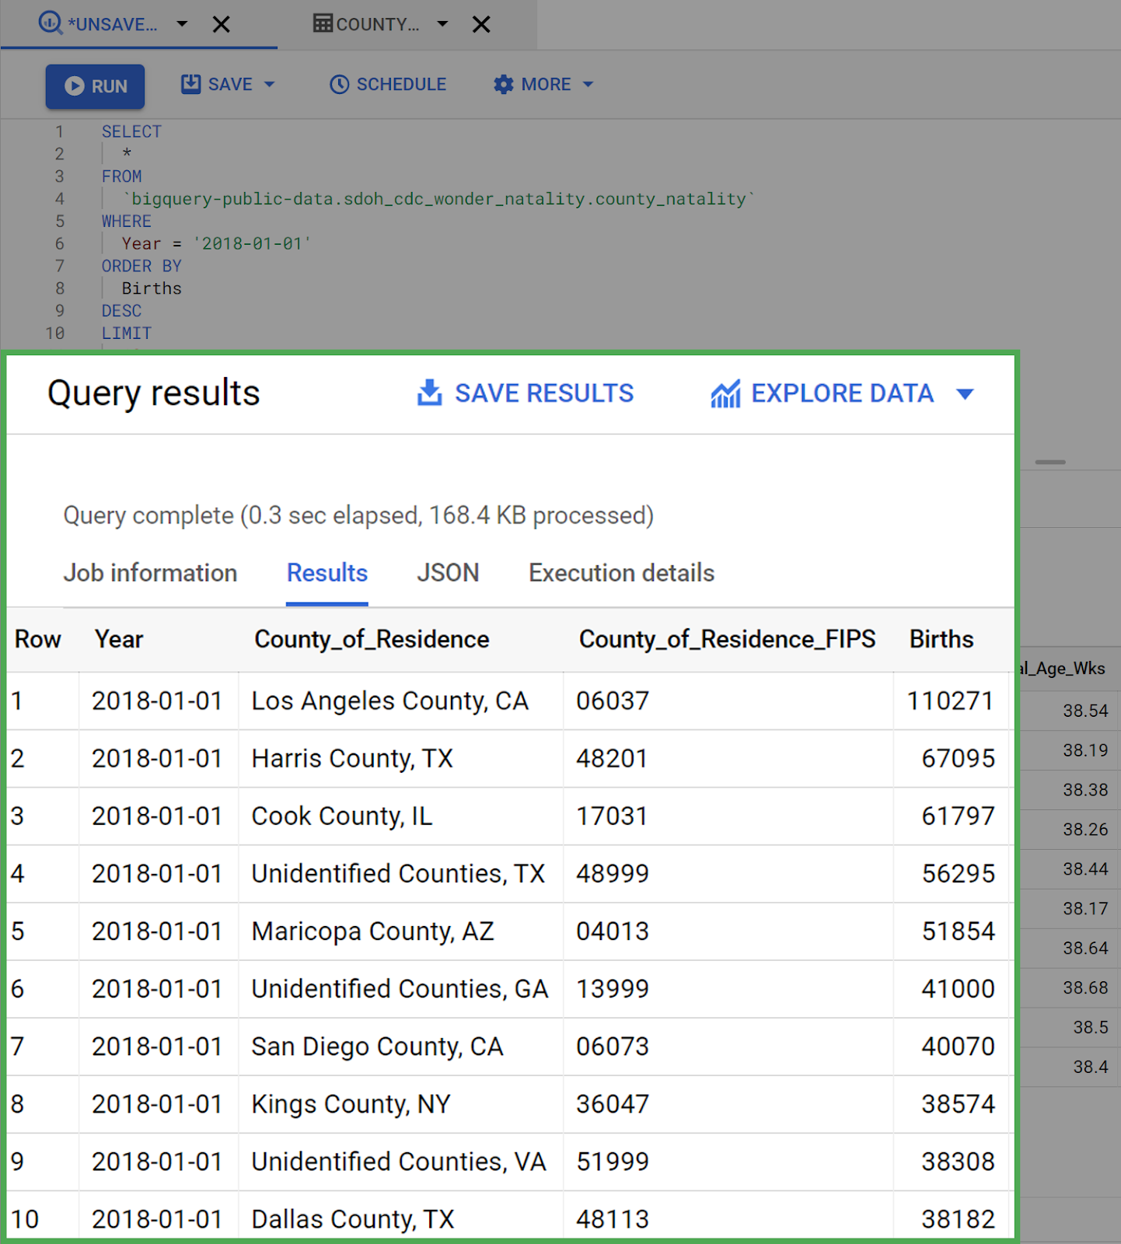

The query worked! You successfully used both ORDER BY and WHERE clauses in the same query.

## Confirmation and reflection



The last query you ran returned the top 10 counties with the highest birth counts for 2018 only. Remove the LIMIT statement and run the query again. What is the county with the 11th highest birth count?

**1 / 1 point**

Orange County, CA

Dallas County, TX

Unidentified Counties, KY

Miami-Dade County, FL

**Correct**

The county with the 11th highest birth count in 2018 is Orange County, CA. To find this answer, you ran a query with an ORDER BY clause and a WHERE clause. Going forward, you can use this knowledge of SQL to better organize and structure your data.

2.

Question 2

In this activity, you practiced sorting data using SQL queries with ORDER BY and WHERE clauses. In the text box below, write 2-3 sentences (40-60 words) in response to each of the following questions:

* How can the ORDER BY clause help you organize and structure your data?
* Why is it helpful to use the ORDER BY and WHERE clauses together when sorting and filtering data?
* Can you think of a business question that you could answer using this method?

**1 / 1 point**

Order by clause is the best clause it can help us to organize data in ascending or descending order. And it's very convenient to use this compare to a spreadsheet. If we want to retrieve very specific data we can use this. both order by and where clause gives us the power to retrieve what we want from the datasets.

**Correct**

Congratulations on completing this hands-on activity! A good response would include that sorting the data you return in your queries is a crucial tool for analyzing and understanding data.

You can also answer business questions by sorting the dataset according to a given metric. For instance, a store may want to know which products they sell the most or least. Sorting helps you answer business questions that involve phrases such as “how much,” “how many,” “best,” or “worst”—which will be a valuable skill in your career as a data analyst.